# General Formulas

BEM

* Inputs: , , ()

1. Angle ϕ
2. Angle of attack

(with from Turbine blade lookup table)

1. Normal and tangential force coefficients

With interpolated from airfoil data

1. Prandtl correction factor:

with c from Turbine blade lookup table

1. Induction factors
2. Classic Gaulert

* :
* :

Tangential induction factor with underrelaxation

1. Madsen

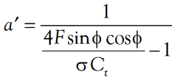

# Task 1

Power & Thrust coefficient

* Power Coefficent

From 

can be expressed as

* Thrust coefficient:

From Eq. 6.31 

can be expressed as

# Task 2

* Power
* Rotational speed